**Install VMware Horizon Client**

**for Windows**

Please follow the below instructions to install the VMware Horizon Client for Windows.

1. Download VMware at [https://vdi.ji.sjtu.edu.cn](https://vdi.ji.sjtu.edu.cn/?includeNativeClientLaunch=true)
2. Download the VMware Horizon Client installer follow below picture.

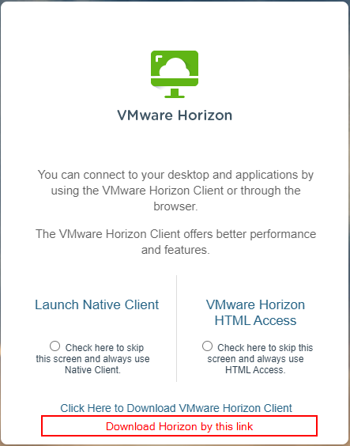

1. Double click on the VMware Horizon Client .exe file to launch the installation.

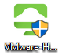

1. If a “Security Warning” window appears, click on the “**Run” or “Yes**” button.

[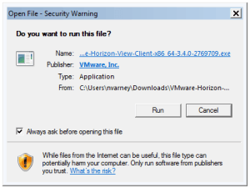](https://cdn1.sph.harvard.edu/wp-content/uploads/sites/44/2015/09/Security-Ask.png)

1. A normal application install window will appear. Click on the  **“Agree & Install”** button**.**

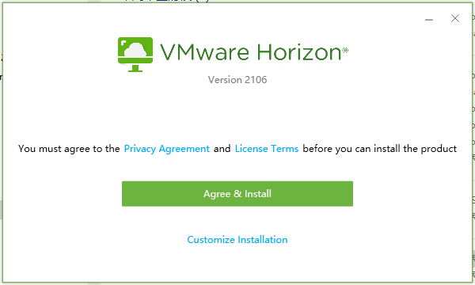

1. Once the installation completes, click on the **Finish** button.



1. You will be prompted to restart your computer, click “**Restart Now**”.

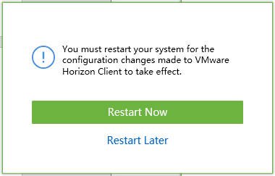

1. When you open up VMware Horizon Client click “ **Add Server 1 ” or “Add Server 2 .”**

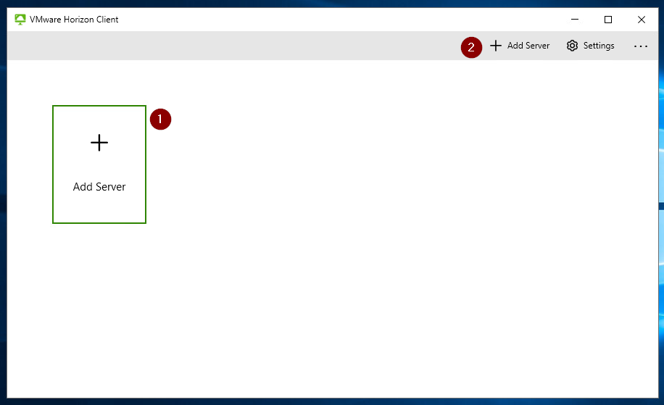

1. 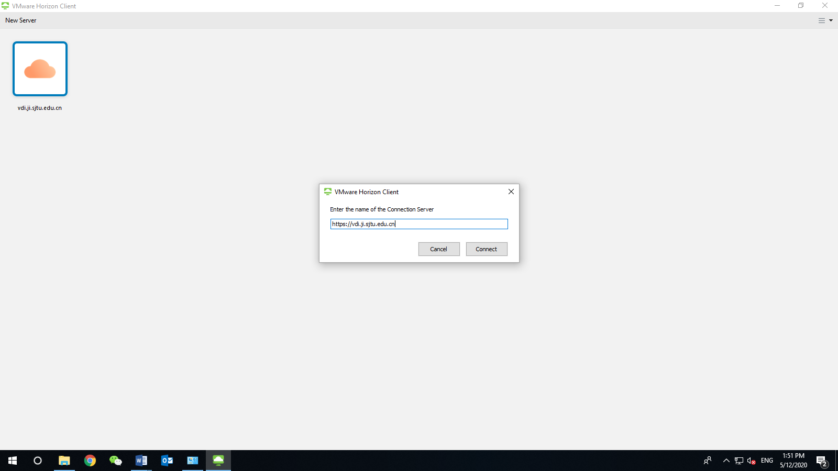Type in **https://vdi.ji.sjtu.edu.cn** and click “**Connect**”.
2. Log in with your jAccount. After logging in the VDI successfully, you can change your initial password by “**Ctrl+Alt+Delete**” )  
   
3. Open document to be printed in VDI. (Please refer to the instruction “Share Access to Local Folders and Drives”).
4. Choose the right printer: **UMJI Printer on printer**.

